EXPERIMENT – 36
AIM :
To develop a Python program that reads stock closing prices from a CSV file and analyzes the variability of stock prices by calculating statistical measures and providing insights into price movements.
ALGORITHM :
- Load the stock data from a CSV file.
- Extract the closing price column.
- Calculate:
  - Mean closing price
  - Standard deviation (variability)
  - Minimum and maximum prices
  - Daily price changes
- Plot closing price trend (optional).
- Display variability insights.

CODE :
import pandas as pd
import numpy as np
import matplotlib.pyplot as plt
import os

# File name
file_name = "stock_data.csv"

# ✅ Check if file exists
if os.path.exists(file_name):
data = pd.read_csv(file_name)
print("✅ File loaded successfully!")
else:
print("⚠️ File not found! Creating sample stock data...\n")

# ✅ Create sample data
data = pd.DataFrame({
'Close': [152.3, 154.1, 150.9, 153.5, 155.2, 151.8, 152.9]
})

# Extract closing prices
close_prices = data['Close']

# Calculate variability
mean_price = close_prices.mean()
std_dev = close_prices.std()
min_price = close_prices.min()
max_price = close_prices.max()

# Display results
print("=== Stock Price Variability Report ===")
print(f"Mean Closing Price : {mean_price:.2f}")
print(f"Standard Deviation : {std_dev:.2f}")
print(f"Lowest Closing Price : {min_price:.2f}")
print(f"Highest Closing Price : {max_price:.2f}")

# Plot the trend
plt.plot(close_prices, marker='o')
plt.title("Stock Closing Price Trend")
plt.xlabel("Days")
plt.ylabel("Closing Price")
plt.grid(True)
plt.show()

INPUT :
A CSV file named stock_data.csv containing a Close column with daily closing prices.If the file is missing, the program uses sample closing price values automatically.

OUTPUT :
⚠️ File not found! Creating sample stock data...

=== Stock Price Variability Report ===
Mean Closing Price : 152.96
Standard Deviation : 1.49
Lowest Closing Price : 150.90
Highest Closing Price : 155.20
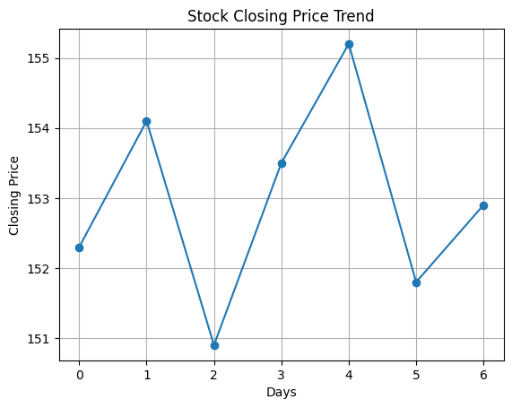

RESULT :
The program successfully calculates stock price variability and provides insights using statistical measures such as mean, standard deviation, minimum, and maximum values. This helps the finance company understand how much the stock fluctuates over time and assess its stability.

